AUTISM SPECTRUM DISORDER PREDICTION

A Project Report

Submitted by:

JAI PRAKASH(GU-2024-1746)

In partial fulfillment for the award of the degree
of
MASTER OF COMPUTER APPLICATION
At



SCHOOL OF COMPUTATIONAL SCIENCE
GNA UNIVERSITY
SRI HARGOBINDGARH, PHAGWARA – HOSHIARPUR ROAD, PHAGWARA-144401, PUNJAB
INDIA

AUTISM SPECTRUM DISORDER PREDICTION

A Project Report

Submitted by:

JAI PRAKASH(GU-2024-1746)

In partial fulfillment for the award of the degree
of
MASTER OF COMPUTER APPLICATION
At



SCHOOL OF COMPUTATIONAL SCIENCE
GNA UNIVERSITY
SRI HARGOBINDGARH, PHAGWARA – HOSHIARPUR ROAD, PHAGWARA-144401, PUNJAB
INDIA

CANDIDATE’S DECLARATION

I hereby certify that the project entitled “Autism Spectrum Disorder Prediction” submitted by(Jai prakash) & (GU-2024-1746) in partial fulfillment of the requirement for the award of degree of the MCA (Master of Computer Applications) submitted in SCS, GNA University is an authentic record of my own work carried out during a period from Jan, 2026 to June, 2026 under the guidance of Prof.( Mr.Prabhat, Assistant professor, SCS). The matter presented in this project has not formed the basis for the award of any other degree, diploma, fellowship or any other similar titles.

Signature of the Student Place:
Place:
Date:


GNA University
School of Computational Science

Date.....................

CERTIFICATE

This is to certify that the project titled “Autism Spectrum Disorder Prediction” is the bona fide work carried out by Jai prakash(GU-2024-1746) in partial fulfillment of the requirement for the award of degree of the MCA submitted in SCS, GNA University is an authentic record of my own work carried out during a period from Jan, 2026 to June, 2026 under the guidance of (Mr Prabhat, Assistant Professor, SCS). The matter presented in this project has not formed the basis for the award of any other degree, diploma, fellowship or any other similar titles.

Signature of the Supervisor/ Guide Signature of the HoD/Dean,SCS

COMPANY CERTIFICATES

ACKNOWLEDGEMENT

I express my sincere gratitude to the GNA University, Phagwara for giving me the opportunity to work on the Project during my final year of MCA.
I would like to thank Dr. Vikrant Sharma, Dean and Dr. Hitesh Marwaha, Head of Department, SCS at GNA University, Phagwara for their kind support.
I also owe my sincerest gratitude towards Prof. Mr.Prabhat for his valuable advice and healthy criticism throughout my project which helped me immensely to complete my work successfully.
I would also like to thank everyone who has knowingly and unknowingly helped me throughout my work. Last but not least, a word of thanks for the authors of all those books and papers which I have consulted during my project work as well as for preparing the report.

ABSTRACT

Autism Spectrum Disorder (ASD) is a neurodevelopmental condition that affects an individual’s communication, behavior, and social interaction. Early identification of autism is crucial, as it enables timely intervention and improves the quality of life for affected individuals. Traditional diagnostic methods often require significant time and expert involvement, which can delay detection. Therefore, this project focuses on developing a machine learning-based system to predict autism traits efficiently and accurately.
The proposed system utilizes a structured dataset containing behavioral screening responses, demographic information, and medical history attributes. The data is preprocessed through techniques such as handling missing values, encoding categorical variables, and feature selection to improve model performance. Various classification algorithms, including Logistic Regression, Decision Tree, Random Forest, and Naive Bayes, are implemented and compared to identify the most effective model.
The performance of these models is evaluated using metrics such as accuracy, precision, recall, and F1-score to ensure reliability and robustness. Experimental results indicate that the proposed approach can achieve high prediction accuracy, demonstrating its potential as a supportive tool in autism screening.
This system can assist healthcare professionals and caregivers by providing a quick and preliminary assessment of autism traits, thereby facilitating early diagnosis and intervention. However, it is important to note that the model is intended for support purposes only and does not replace professional medical diagnosis.
Keywords: Autism Spectrum Disorder (ASD), Machine Learning, Classification, Early Detection, Behavioral Analysis, Data Preprocessing, Healthcare, Predictive Modeling.

LIST OF FIGURES
Fig. No.

Figure Description

Page No.

3.2.1 DFD 10
3.2.2 DFD level 0 11
3.4.1 Front page 13
3.4.2 Analysis 1 13
3.4.3 Analysis 2 14
3.4.4 power BI Dashboard 14
4.1 Front page 28
4.2 Analysis 28
4.3 Power BI Dashboard 30

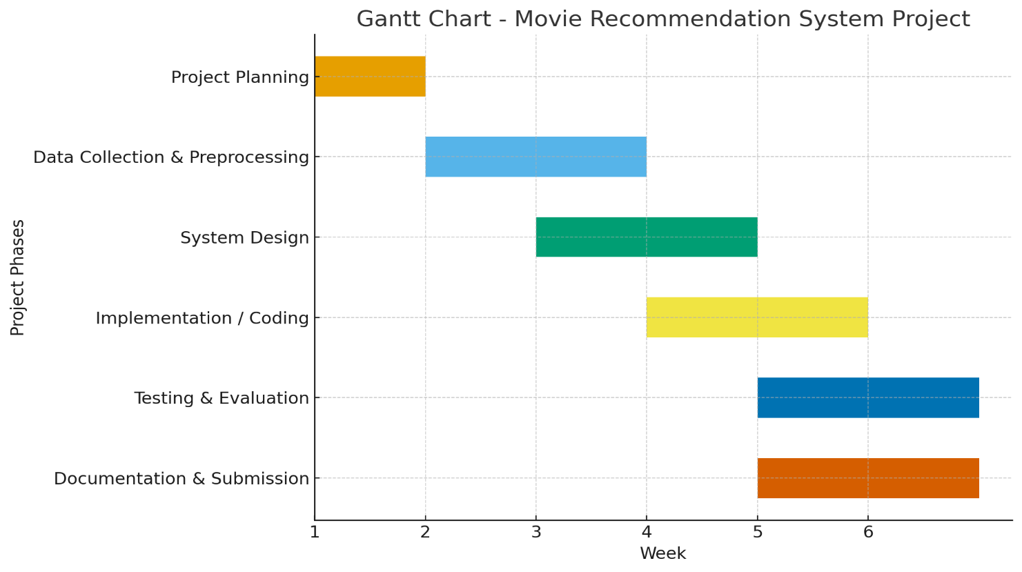
Timeline/Gantt Chart

Table of Content Title...................................................................................................................................................i
Declaration of the Student...............................................................................................................ii
Certificate of the Guide...................................................................................................................iii
Company Certificates......................................................................................................................iv
Acknowledgement...........................................................................................................................v
Abstract…...……............................................................................................................................vi
List of Figures................................................................................................................................vii
Timeline/ Gantt Chart...................................................................................................................viii
- INTRODUCTION
1.1 Problem Definition.....................................................................................................................1
1.2 Project Overview........................................................................................................................2
1.3 Hardware Specification..............................................................................................................3
1.4 Software Specification...............................................................................................................3
- LITERATURE SURVEY
2.1 Existing System..........................................................................................................................4
2.2 Proposed System........................................................................................................................4
2.3 Feasibility Study.........................................................................................................................5
- SYSTEM ANALYSIS AND DESIGN
3.1 Requirement Specification........................................................................................................7
3.2 DFD/ERD.................................................................................................................................10
3.3 Design/Criteria.........................................................................................................................13
3.4 Source Code.............................................................................................................................15
3.5 Testing Process.........................................................................................................................26
- RESULTS/ OUTPUTS…………………………………………………………………….28
- CONCLUSION…………………………………………………………………………….29
- REFERENCES………...…………………………………………………………………...30
- APPENDICES………...……………………………………………………………………31
CHAPTER 1
INTRODUCTION
  - Problem Definition
Autism Spectrum Disorder (ASD) is a condition that affects how a person communicates, interacts with others, and behaves. Every individual with autism is different, and the symptoms can range from mild to severe. Some people may have difficulty speaking and understanding social situations, while others may show repetitive behaviors or strong sensitivity to sounds, lights, or touch. Because autism affects a child’s development from an early age, identifying it as soon as possible is very important. Early detection allows parents, teachers, and healthcare professionals to provide the right support and therapies, which can significantly improve the individual’s learning, communication, and overall quality of life.
At present, autism is usually diagnosed by trained doctors, psychologists, or specialists through behavioral observations, interviews, and screening tests. These methods are accurate and trusted, but they often take a considerable amount of time and may be expensive. In many areas, especially rural or underdeveloped regions, there may not be enough specialists available to perform these assessments. As a result, families may wait months or even years before receiving a diagnosis. During this delay, valuable time that could have been used for early intervention is lost.
With the advancement of Machine Learning and data science, computers can now be trained to recognize patterns in large amounts of information. Machine learning models can study behavioral and demographic data, such as age, gender, family history, and responses to autism screening questions, and use this information to predict whether a person is likely to show autism-related traits. This approach can provide quick and consistent results, making the screening process more efficient and accessible.
However, creating such a predictive system is not straightforward. The data collected for autism screening contains both numerical and categorical values, and some entries may be missing or inconsistent. Therefore, the data must be carefully cleaned and prepared before it can be used. In addition, several machine learning algorithms need to be tested to determine which one gives the most accurate predictions. Choosing the right features and the best-performing model is essential to ensure that the system produces reliable results.
The main problem addressed in this project is to build a machine learning-based system that can analyze behavioral and demographic information and predict the likelihood of Autism Spectrum Disorder. The goal is to create a tool that can assist healthcare professionals, parents, and caregivers by providing a fast and accurate preliminary assessment. This tool is not intended to replace doctors or clinical diagnosis, but rather to serve as a supportive screening system that identifies individuals who may need further professional evaluation.
In simple terms, this project aims to use technology to make autism screening faster, easier, and more accessible. By developing an accurate prediction model and integrating it into a user-friendly application, the project seeks to help families and healthcare providers detect autism traits earlier and take timely action. Early support can make a significant difference in the development and future well-being of individuals with autism and their families.

  - Project Overview
The Autism Prediction System is an intelligent healthcare application developed using Machine Learning techniques to support the early screening of Autism Spectrum Disorder (ASD). Autism is a neurodevelopmental condition that affects a person’s ability to communicate, interact socially, and respond to the surrounding environment. Since early intervention plays a critical role in improving developmental outcomes, the ability to identify autism-related traits at an early stage is of great importance. This project aims to provide a fast, reliable, and data-driven system that assists healthcare professionals, educators, and caregivers in detecting potential autism indicators and making timely decisions regarding further evaluation and support.
The core objective of the project is to build a predictive model capable of analyzing behavioral and demographic information to determine the likelihood that an individual exhibits autism traits. Traditional diagnostic procedures involve extensive clinical assessments, interviews, and observations conducted by trained specialists. While these methods are effective, they are often time-consuming, expensive, and inaccessible in many regions where autism experts and diagnostic facilities are limited. The Autism Prediction System addresses this challenge by leveraging machine learning algorithms to automate the screening process and provide instant predictions based on structured input data.
The project begins with the collection of autism screening datasets obtained from publicly available and research-oriented data repositories. These datasets typically contain a combination of personal and behavioral features, including age, gender, ethnicity, family history of autism, history of jaundice at birth, country of residence, and responses to standardized screening questions designed to measure autism-related behaviors. These features capture important information that can help machine learning models identify patterns associated with ASD.
Before model development, the raw dataset undergoes a comprehensive preprocessing stage to improve data quality and ensure compatibility with machine learning algorithms. This process includes removing duplicate records, handling missing values, correcting inconsistent entries, and detecting outliers. Categorical variables such as gender and family history are transformed into numerical representations using encoding techniques such as label encoding and one-hot encoding. Numerical features are scaled or normalized when necessary to improve model performance. Feature selection methods are also applied to identify the most influential attributes, reducing noise and enhancing prediction accuracy while minimizing computational complexity.
Once the data has been prepared, it is divided into training and testing subsets. The training set is used to teach the models how to recognize patterns in the data, while the testing set is used to evaluate how well the models perform on unseen information. Several supervised learning algorithms are implemented and compared, including Logistic Regression, Decision Tree, Random Forest, Naive Bayes Classifier, Support Vector Machine, and K-Nearest Neighbors Algorithm. Each algorithm offers unique strengths, and their comparative analysis helps determine the most suitable model for autism prediction.
Model performance is assessed using a range of evaluation metrics to ensure that the selected classifier is both accurate and dependable. These metrics include accuracy, precision, recall, F1-score, confusion matrix analysis, and Receiver Operating Characteristic (ROC) curves. Special attention is given to recall and F1-score because, in medical screening applications, correctly identifying individuals who may have autism is often more important than minimizing false alarms. Hyperparameter tuning techniques such as Grid Search and cross-validation are employed to optimize model settings and improve generalization performance.
After evaluating all candidate models, the best-performing algorithm is selected as the final prediction engine. This model is serialized and integrated into an easy-to-use application interface developed using tools such as Streamlit or Flask. Through this interface, users can enter demographic and behavioral information and receive an immediate prediction indicating whether autism traits are likely to be present. The interface may also display confidence scores, model explanations, and visual summaries to help users better understand the prediction results.
In addition to the predictive model, the project demonstrates the practical application of data science in the healthcare domain. It highlights the importance of proper data preprocessing, thoughtful feature engineering, model comparison, and rigorous evaluation. The project also emphasizes ethical considerations such as privacy, responsible use of predictions, and the understanding that the system is intended solely as a screening aid rather than a replacement for professional medical diagnosis.
The Autism Prediction System offers several potential benefits. It can reduce the time required for initial screening, improve access to early assessment tools, and support decision-making in areas where specialists are scarce. It can also be used as an educational and research tool to explore how machine learning techniques can solve real-world healthcare problems. By combining predictive analytics with an accessible user interface, the project demonstrates how artificial intelligence can contribute to improving early detection and intervention strategies.
Overall, the Autism Prediction System is a comprehensive machine learning project that integrates data collection, preprocessing, model development, evaluation, optimization, and deployment into a single end-to-end solution. The project not only showcases technical skills in machine learning and application development but also addresses an important social and healthcare challenge. By enabling faster and more accessible autism screening, the system has the potential to assist families and healthcare providers in identifying autism traits earlier and facilitating timely support, ultimately improving the lives of individuals with autism and their communities.

1.3 Hardware Specification
- Processor: Intel Core i5 or higher
- RAM: Minimum 8 GB (Recommended 16 GB)
- Storage: 256 GB SSD or higher
- Operating System: Windows 10 / Linux / macOS
- Internet Connection: Required for data collection and visualization
1.4 Software Specification
- Programming Language: Python
- Development Environment: Jupyter Notebook / Google Colab / VS Code
- Visualization Tools: Streamlit,Power BI
- Libraries Used: Pandas, NumPy, Matplotlib, Seaborn, Scikit-learn
- Data Sources: Kaggle/Autism Prediction.csv (CSV/Excel format)

CHAPTER 2
LITERATURE SURVEY
2.1 Existing System
The existing system for identifying Autism Spectrum Disorder (ASD) is mainly based on traditional clinical evaluation methods performed by experienced healthcare professionals such as pediatricians, psychologists, psychiatrists, and developmental specialists. These experts assess a child’s behavior, communication skills, and social interactions to determine whether autism-related traits are present. The process typically includes interviews with parents or caregivers, direct observation of the child, and the use of standardized screening questionnaires and diagnostic tools.
In a typical clinical setting, parents are asked a series of questions about their child’s developmental history, language abilities, social behavior, and daily habits. Doctors and specialists also observe how the child responds to eye contact, communicates with others, reacts to sounds and sensory stimuli, and engages in repetitive behaviors. Based on these observations and test results, the specialist determines whether the child meets the diagnostic criteria for autism. These methods are widely accepted and are considered the most reliable approach for making a formal diagnosis.
Although the existing system is effective, it has several practical limitations. One of the biggest challenges is that the diagnostic process can take a significant amount of time. Families often need to schedule multiple appointments, complete lengthy assessments, and wait weeks or even months for a final evaluation. In many cases, this delay can be stressful for parents who are concerned about their child’s development and are eager to begin intervention as early as possible.
Another major limitation is the high cost associated with professional assessments. Comprehensive autism evaluations often involve multiple specialists and detailed testing procedures, which can be expensive and may not be affordable for all families. In addition, many healthcare systems have a shortage of trained autism specialists. This problem is especially common in rural and underdeveloped areas, where families may need to travel long distances to access appropriate diagnostic services. As a result, many children do not receive timely assessments, and valuable opportunities for early support may be missed.
The existing system also depends heavily on the experience and judgment of healthcare professionals. While specialists are highly trained, human evaluation can sometimes involve a degree of subjectivity. Different professionals may interpret certain behaviors in slightly different ways, which can lead to variations in assessment outcomes. Furthermore, clinicians must manually review large amounts of behavioral and demographic information, making the process labor-intensive and difficult to scale when the number of patients increases.
Traditional diagnostic methods are also limited in their ability to analyze large datasets and uncover hidden relationships among multiple factors. For example, variables such as age, gender, family history, and responses to screening questions may contain patterns that are not immediately obvious to human observers. Without advanced computational tools, these complex patterns may remain undiscovered, reducing the potential for faster and more objective screening.
Another challenge is that conventional systems do not provide instant results. Families often wait a long time between the initial screening and the final diagnosis. During this waiting period, uncertainty can create emotional stress, and children may miss the critical developmental window during which therapies and interventions are most effective. Since early intervention is one of the most important factors in improving outcomes for children with autism, any delay in detection can have a significant impact.
In addition, most existing systems are designed primarily for diagnosis rather than preliminary screening. They are intended to confirm autism after concerns have already been raised, rather than to provide a quick and accessible way to identify individuals who may need further assessment. This creates a gap between the first signs of developmental differences and the formal diagnostic process.
Because of these limitations, there is a growing need for a more efficient, affordable, and accessible screening approach. A system that can automatically analyze behavioral and demographic data and provide an early indication of autism risk would greatly assist both healthcare professionals and families. Machine Learning offers this possibility by enabling computers to learn patterns from historical data and make accurate predictions within seconds.
By integrating machine learning into autism screening, it becomes possible to reduce the time required for preliminary assessment, improve consistency, and make screening tools available to a much wider population. Such systems can support specialists by identifying individuals who are more likely to exhibit autism traits and should undergo detailed clinical evaluation. They can also help in regions where expert resources are limited.
In summary, the existing system for autism diagnosis is based on trusted clinical methods and expert assessments, but it is often slow, expensive, and dependent on specialized professionals. It lacks automation, scalability, and the ability to efficiently analyze large amounts of data. These challenges highlight the need for an intelligent and data-driven solution that can complement traditional diagnostic practices and make early autism screening faster, more objective, and more accessible to everyone.

2.2 Proposed System
The proposed system is designed to provide a smart, efficient, and automated solution for the early prediction of Autism Spectrum Disorder (ASD) using Machine Learning techniques. The main objective of this system is to assist healthcare professionals, parents, and caregivers by offering a quick and reliable method for identifying autism-related traits based on behavioral and demographic information. Unlike traditional diagnostic approaches, which require detailed clinical assessments and specialist interpretation, the proposed system uses data-driven algorithms to generate predictions within seconds, making the screening process faster, more accessible, and more cost-effective.
The system begins with the collection of autism screening data obtained from publicly available datasets and standardized questionnaires. These datasets contain a variety of attributes that are commonly associated with autism assessment, including age, gender, ethnicity, family history of autism, history of jaundice at birth, country of residence, and responses to behavioral questions that evaluate social communication and repetitive behaviors. The target variable in the dataset indicates whether an individual is likely to exhibit autism traits. By using these features, the system can learn meaningful patterns that distinguish individuals with autism-related characteristics from those without them.
After data collection, a comprehensive preprocessing phase is carried out to improve the quality and consistency of the dataset. Real-world data often contains missing values, duplicate entries, and categorical variables that cannot be directly used by machine learning algorithms. To address these issues, missing values are handled using appropriate imputation techniques, duplicate records are removed, and categorical features are converted into numerical form using encoding methods such as label encoding. Numerical attributes may also be scaled or normalized to ensure that all features contribute equally during model training. These preprocessing steps are essential for improving the stability, efficiency, and predictive performance of the models.
Once the data is prepared, Exploratory Data Analysis (EDA) is performed to gain a deeper understanding of the dataset. During this stage, statistical summaries and visualizations are used to examine the distribution of features, identify outliers, detect correlations, and uncover hidden trends. This analysis helps determine which features have the strongest influence on autism prediction and supports better decision-making during feature selection and model development. EDA also provides valuable insights into the nature of the data and ensures that potential issues are identified before training begins.
The next phase involves implementing multiple supervised machine learning classification algorithms. In this project, models such as Decision Tree, Random Forest, and Extreme Gradient Boosting are trained using the processed dataset. Each model learns from historical examples and attempts to classify individuals as either likely or unlikely to exhibit autism traits. These algorithms are chosen because they are well-suited for classification problems and are capable of capturing complex relationships within the data.
To ensure that the models are evaluated fairly, the dataset is divided into training and testing subsets. The training set is used to teach the models, while the testing set is reserved for assessing their performance on previously unseen data. This approach provides a realistic measure of how well the models are expected to perform in real-world scenarios. Additional validation techniques such as cross-validation and hyperparameter tuning may also be used to optimize model settings and further improve prediction accuracy.
Model evaluation is conducted using several widely accepted performance metrics, including accuracy, precision, recall, F1-score, and confusion matrix analysis. These metrics provide a detailed understanding of each model’s strengths and weaknesses. In healthcare applications, recall is especially important because it measures the system’s ability to correctly identify individuals who may have autism and should undergo further assessment. After comparing all models, the Random Forest classifier is selected as the final model because it demonstrates the highest accuracy, strong generalization capability, and robustness in handling both numerical and categorical data.
The selected model is then saved and integrated into a practical prediction framework. This framework can accept new user inputs and instantly predict whether autism traits are likely to be present. To make the system easy to use, it can be deployed through an interactive interface developed with Streamlit. Through this interface, users can enter relevant information and receive real-time predictions along with confidence scores and visual explanations. This user-friendly design ensures that the system can be used by individuals with limited technical knowledge.
The proposed system offers several important advantages over traditional diagnostic approaches. It significantly reduces the time required for preliminary screening, lowers costs, and improves accessibility for families and healthcare providers in underserved regions. It also provides objective and consistent predictions based on data patterns rather than solely relying on manual interpretation. By automating the screening process, the system can help specialists focus their attention on individuals who are most likely to require detailed clinical evaluation.
It is important to emphasize that the proposed system is intended as a decision-support and screening tool rather than a replacement for professional medical diagnosis. Its purpose is to assist in identifying individuals who may show autism-related traits so that they can be referred to qualified healthcare professionals for comprehensive assessment. This responsible approach ensures that machine learning is used to complement, rather than substitute, expert clinical judgment.
In conclusion, the proposed Autism Prediction System presents an automated, reliable, and efficient solution for the early detection of autism traits. By combining data preprocessing, exploratory data analysis, machine learning model development, rigorous evaluation, and real-time deployment, the system addresses many of the limitations of traditional diagnostic methods. The project demonstrates how artificial intelligence can be applied in healthcare to improve screening processes, support early intervention, and ultimately contribute to better developmental outcomes and quality of life for individuals with autism and their families.

2.3 Feasibility Study
The feasibility analysis for the proposed project, “Autism Spectrum Disorder Prediction Using Machine Learning,” has been carried out from technical, operational, and economic perspectives to evaluate its practicality and effectiveness. The detailed findings are presented below:
1. Technical Feasibility:The proposed system is technically feasible as it is built using well-established and widely accepted technologies in the domain of data science and machine learning. Python is employed as the primary programming language due to its simplicity, flexibility, and extensive ecosystem of libraries. Core libraries such as Pandas and NumPy are used for data manipulation and preprocessing, while Matplotlib and Seaborn are utilized for data visualization and exploratory analysis.
For model development, Scikit-learn provides efficient implementations of machine learning algorithms, including Decision Tree, Random Forest, and XGBoost classifier. These algorithms are capable of handling both linear and non-linear relationships within the dataset, ensuring reliable prediction performance.
The dataset used for autism prediction is available in structured formats such as CSV, allowing seamless data integration and preprocessing. The computational requirements of the system are minimal, and it can be efficiently executed on a standard personal computer with moderate specifications (minimum 8 GB RAM). Furthermore, all tools and technologies used are cross-platform compatible, enabling development and execution on Windows, macOS, and Linux environments without any constraints.
2. Operational Feasibility: From an operational perspective, the project is highly practical and can be effectively implemented within an academic setting. The workflow is well-defined and follows a systematic approach, making it manageable for a student or a small development team with foundational knowledge of machine learning.

The operational flow of the system includes:
• Collection of autism screening data from reliable sources
• Data preprocessing, including handling missing values, encoding categorical variables, and feature scaling
• Performing Exploratory Data Analysis (EDA) to understand data distribution and relationships
• Training multiple machine learning models for classification• Evaluating model performance using standard metrics
• Selecting the optimal model for prediction and deployment
The system can be further enhanced with a user friendly interface, allowing non-technical users to input data and obtain predictions easily. The outcomes generated by the system provide meaningful insights and can support healthcare professionals and caregivers in early-stage autism screening. This ensures that the project is not only academically significant but also practically applicable.
3. Economic Feasibility: The proposed system is economically viable as it is developed entirely using open-source tools and freely available resources. Python and its associated libraries are available at no cost, and development platforms such as Jupyter Notebook and Google Colab provide free environments for coding and experimentation.
The dataset used for the project is publicly accessible, eliminating the need for any data acquisition costs. Additionally, the system does not require any specialized hardware or paid software licenses, as it can be executed on a standard personal computer. Therefore, the overall development and implementation cost is negligible.
This cost-effectiveness makes the project highly suitable for academic purposes and ensures accessibility for students and educational institutions without imposing any financial burden.

CHAPTER 3
SYSTEM ANALYSIS AND DESIGN
3.1 Requirement Specification
3.1.1 Functional Requirements
Data Collection: The system must be capable of acquiring and loading autism screening datasets from reliable and publicly available sources such as research repositories or healthcare datasets. It should support reading data from structured file formats such as CSV or Excel and convert the input into suitable data structures like Pandas DataFrames for further processing.
The system should ensure that the collected dataset contains relevant attributes required for autism prediction, including demographic, medical, and behavioral features. These may include, but are not limited to:
• Age of the individual
• Gender
• Family history of autism
• History of jaundice
• Behavioral screening responses (A1–A10)
• Ethnicity and other demographic details
The system must also validate the integrity and completeness of the data during the collection phase to ensure that it is suitable for preprocessing and model training. Additionally, it should allow flexibility to incorporate new datasets or additional features in the future to enhance model performance and adaptability.

Data Preprocessing:
The system must preprocess the autism dataset to ensure data quality before model training. It should handle:
• Missing values
• Duplicate records
• Inconsistent data formats
The system must convert categorical data into numerical form using encoding techniques and apply scaling to numerical features where required. Finally, all processed data should be organized into a clean and structured DataFrame for efficient model training and analysis.
Data Analysis:
The system must perform data analysis to extract meaningful insights from the autism dataset. It should generate statistical summaries such as:
• Mean, median, and variance of numerical features.
• Descriptive analysis of demographic and behavioral attributes.
• Correlation analysis among features to identify important relationships.
The system should also analyze patterns in behavioral responses (such as A1–A10) to understand their impact on autism prediction and support effective model building.
Predictive Modeling:
Predictive Modeling: The system must implement classification models to predict autism traits based on the given dataset. It should use machine learning algorithms such as:
• Decision Tree
• Random Forest
• XGBoost
These models are trained on the preprocessed dataset to classify whether an individual exhibits autism traits or not. The system should evaluate model performance using appropriate metrics and select the best-performing model.
The final output should provide predictions in an easily interpretable format to assist in early autism screening.

Visualization and Reporting:
Build interactive dashboards using Streamlit for visual exploration.
Visualize trends using:
- Bar charts
- Heatmaps
- Scatter plots
- Allow users to export:
- Data summaries (CSV/Excel)
3.1.2 Non-Functional Requirements
1. Performance
The system should process the autism dataset and complete data preprocessing, model training, and prediction within a reasonable time. The prediction results should be generated quickly (within a few seconds) depending on dataset size and system performance.
The machine learning models (Decision Tree, Random Forest, and XGBoost) should run efficiently on a standard personal computer without requiring high-end hardware.
2. Scalability
The system should be able to handle large autism datasets with multiple features and records efficiently. It must support the addition of new data and features in the future without affecting performance.
The system should also be flexible enough to incorporate improved models or additional attributes to enhance prediction accuracy.

3. Usability
The Streamlit dashboard should be simple, intuitive, and accessible to non-technical users.Clear navigation, labeled charts, and straight forward input selections are required.
4. Reliability
The system should ensure consistent and accurate results across multiple executions. It must handle errors during data preprocessing and model prediction gracefully without system failure.
Data integrity should be maintained throughout the pipeline, ensuring that the input data, processed data, and prediction outputs remain correct and reliable.
5. Portability
The system should run on:
- Windows
- Linux
- macOS
All features must work with standard Python environments (Anaconda/virtualenv).

3.2 DFD (Data Flow Diagram)/ ERD (Entity-Relationship Diagram)
The data flow diagram is a graphical representation that depicts information flow and the transforms that are applied as data moves from input to output. The DFD may be used to represent a system or software at any level of abstraction. In fact DFD may be partitioned into levels that represent increasing information flow and functional detail.

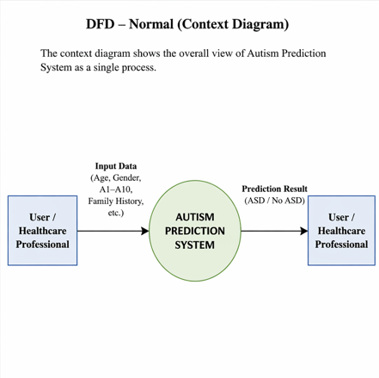

Figure 3.2.1: Process flowchart of the Autism Prediction System in a single process.

DFD Level 0:

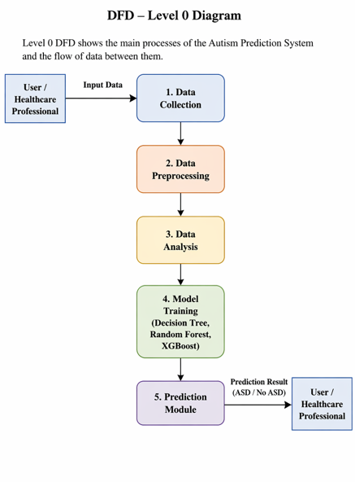

Figure 3.2.2: Data Flow Diagram (Level 0).

ERD (Entity-Relationship Diagram)

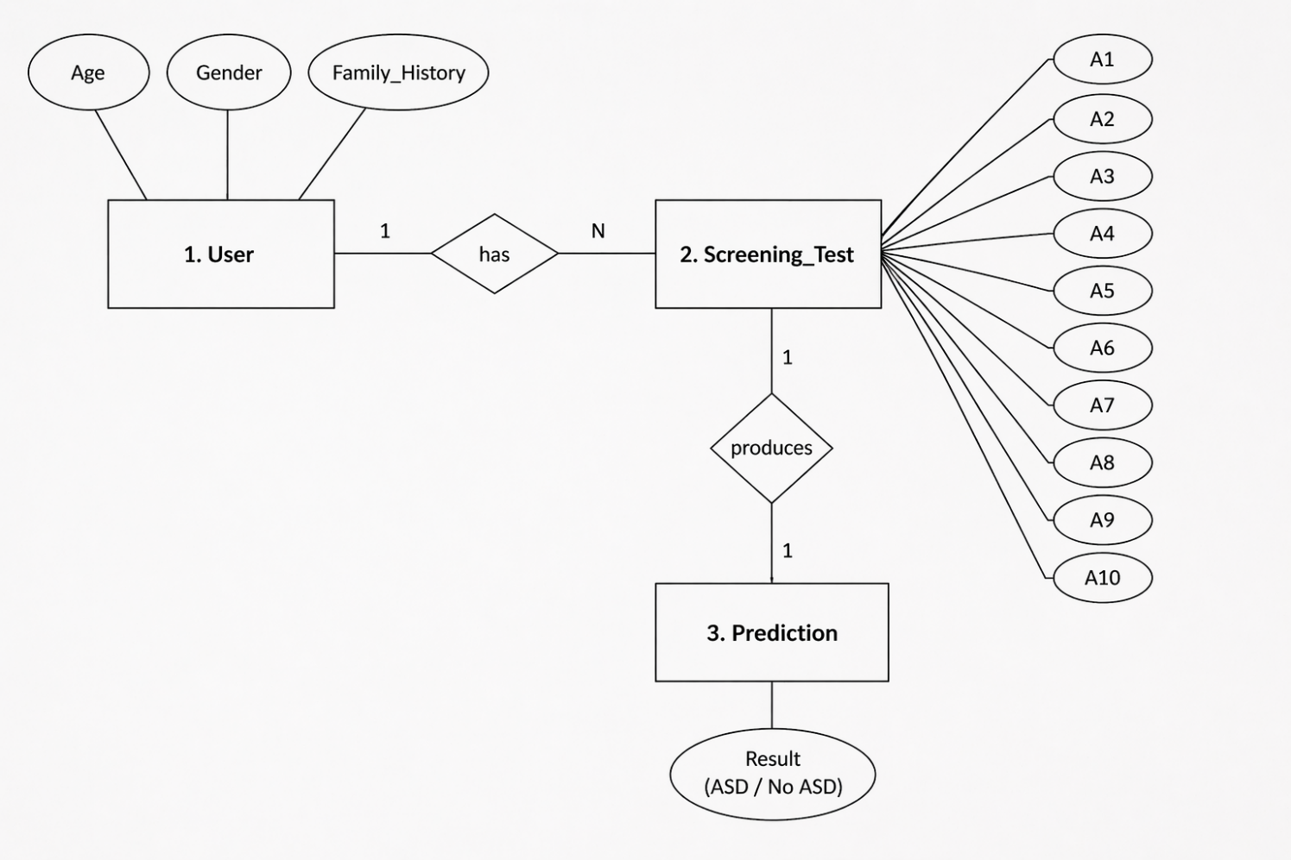

Figure 3.2.2: ER Diagram

  - Design/Criteria
Front Page: : It describes the first interface through which the user interact.
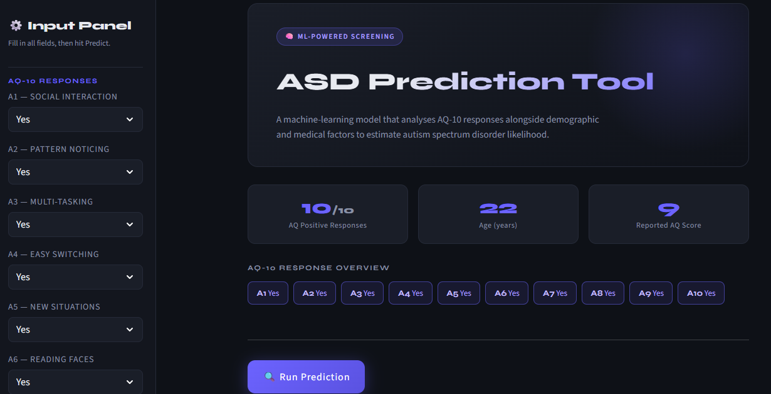
Figure 3.4.1
Analysis: It is showing the analysis based on A1-A9 Score,and Age feature on the basis of Dataset.
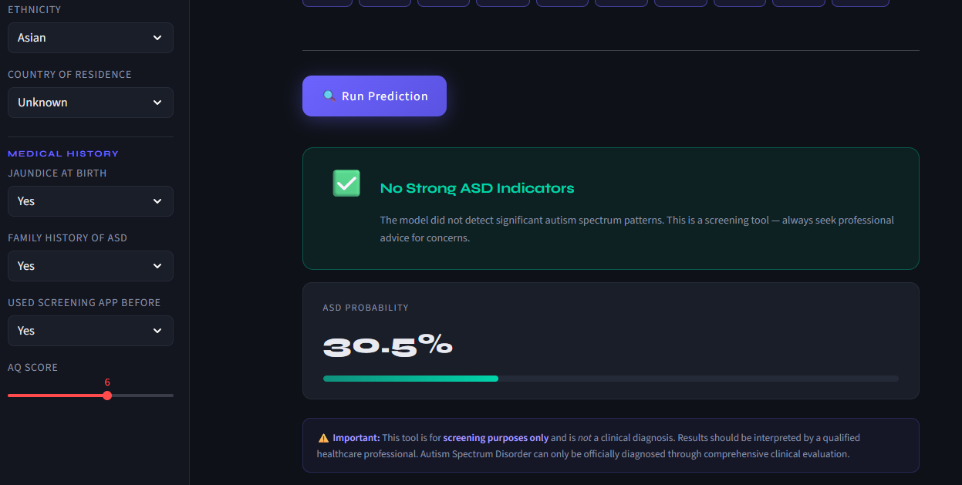
Figure 3.4.2
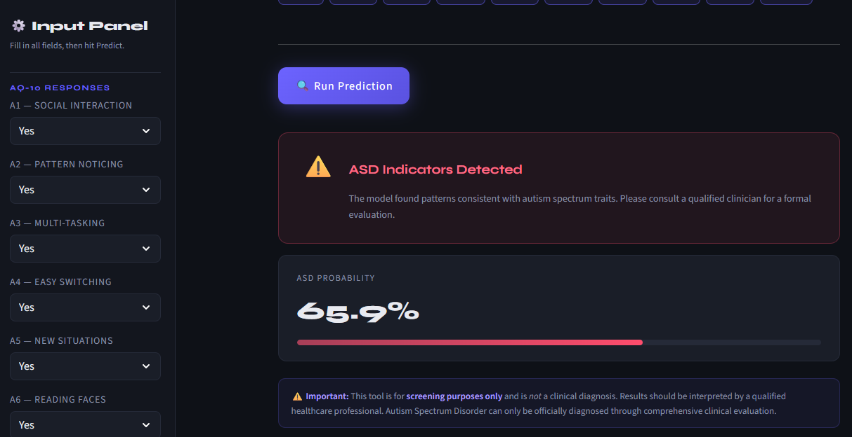
Figure 3.4.3
Power BI: Here is the power BI dashboard where I show the model Accuracy along with multiple input and out features .
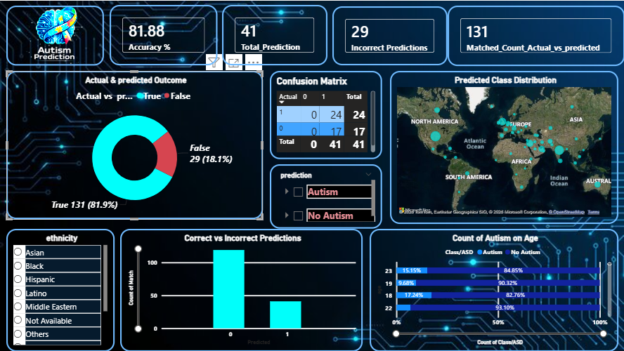
Figure 3.4.4

  - Testing Process
1. Unit Testing
Individual components of the system to ensure that each module functions correctly and produces expected outputs.
• Data Collection Module: Verify correct loading of autism datasets from CSV/Excel files and ensure all required features (Age, Gender, A1–A10, etc.) are properly read into the system.
• Data Preprocessing Module: Check handling of missing values, removal of duplicate records, encoding of categorical variables, and scaling of numerical features. Ensure the dataset is clean and properly formatted for model training.
• Analysis Functions: Validate statistical summaries, feature relationships, and correlation analysis among input variables to ensure correct data insights.
• Model Training Module: Test machine learning models (Decision Tree, Random Forest, XGBoost) for correct training, input/output consistency, and proper handling of training data.
• Prediction Module: Ensure the system correctly predicts autism traits (ASD / No ASD) based on input data and produces accurate and consistent results.

2. Integration Testing
Ensure that all modules work correctly when combined as a complete system.
• Check whether data collection - preprocessing - analysis -model training - prediction flows smoothly without errors.
• Validate that the preprocessed dataset integrates correctly with machine learning models for accurate training and testing.
• Verify that the prediction module correctly uses the trained model to generate results (ASD / No ASD) based on input data.
• Ensure that all components interact seamlessly and produce consistent outputs across the system.
3. System Testing
Test the complete end-to-end system to ensure proper functionality, stability, and performance.
• Ensure the system can handle large autism datasets without crashing or performance issues.
• Test the full workflow including data input, preprocessing, model training, and prediction to verify smooth execution.
• Check whether machine learning models (Decision Tree, Random Forest, XGBoost) generate predictions within acceptable time limits.
• Validate that the final prediction results (ASD / No ASD) are displayed correctly and consistently for different inputs.
• Ensure that outputs and reports can be generated or stored correctly without errors.

4. User Acceptance Testing (UAT)
Conduct testing with end users such as students, healthcare professionals, or evaluators to ensure the system meets user requirements.
  - Confirm that the system interface is easy to use and user-friendly for entering input data (Age, Gender, A1–A10, etc.).
  - Validate that the prediction results (ASD / No ASD) are clear, understandable, and align with expected outcomes.
  - Ensure the overall workflow is smooth, including data input, processing, and result display.
  - Collect feedback from users regarding usability, clarity of results, and ease of interaction with the system.

5. Testing Metrics
Measure the effectiveness and quality of the system using the following metrics:
• Accuracy: Correctness of the machine learning model in predicting autism traits (ASD / No ASD).
• Response Time: Time taken for data preprocessing, model training, and generating predictions.
• Error Rate: Number of incorrect predictions, system errors, or failures during execution.
• User Satisfaction: Feedback on ease of use, clarity of prediction results, and overall user experience.
• Data Consistency: Ensuring that input data, processed data, and prediction outputs remain consistent and reliable throughout the system.

CHAPTER 4
RESULTS/ OUTPUTS
Front Page: It describes the first interface through which the user interact.

Figure 4.1
Analysis:It is showing the analysis based on institution in world bank data.

Figure 4.2
Power BI: Here is the power BI dashboard where I show the model Accuracy along with multiple input and out features.


Figure 4.3

CHAPTER 5
CONCLUSION
Conclusion
In this research, machine learning techniques were applied to predict Autism Spectrum Disorder (ASD) using behavioral and demographic data. Various data preprocessing techniques, including data cleaning, handling missing values, feature selection, encoding, and normalization, were performed to prepare the dataset for effective analysis and model training.
Multiple classification algorithms such as Decision Tree, Random Forest, and XGBoost were implemented and evaluated to identify patterns associated with autism indicators. Among these, ensemble-based models like Random Forest and XGBoost demonstrated superior performance due to their ability to handle complex and non-linear relationships within the data. The evaluation of models was carried out using metrics such as accuracy, precision, recall, and F1-score, ensuring the reliability and robustness of the system.
The results indicate that machine learning models can effectively assist in predicting autism traits with high accuracy, making them valuable tools for early screening. Early detection of ASD is crucial, as it enables timely intervention, improved communication development, and better overall outcomes for affected individuals.
Furthermore, this project highlights the importance of data preprocessing and feature engineering in enhancing model performance. It also demonstrates how data-driven approaches can support healthcare professionals and caregivers by providing quick and preliminary assessments.
However, it is important to note that the proposed system is not a replacement for professional medical diagnosis but rather a supportive tool to aid in decision-making. Overall, this study emphasizes the potential of machine learning in healthcare applications and its role in improving early detection and intervention strategies for Autism Spectrum Disorder.

CHAPTER 6
REFERENCES
[1] S. Rajagopalan, Y. Zhang, A. Yahia, and K. Tammimies, “Machine learning prediction of autism spectrum disorder from a minimal set of medical and background information,” JAMA Network Open, vol. 7, no. 2, pp. 1–12, 2024.
[2] T. Eslami, V. Mirjalili, A. Fong, A. Laird, and F. Saeed, “ASD-DiagNet: A hybrid learning approach for detection of autism spectrum disorder using fMRI data,” Frontiers in Neuroinformatics, vol. 13, pp. 1–15, 2019.
[3] R. Tejwani, A. Liska, H. You, J. Reinen, and P. Das, “Autism classification using brain functional connectivity dynamics and machine learning,” Frontiers in Neuroscience, vol. 11, pp. 1–10, 2017.
[4] P. Thabtah, “Autism spectrum disorder screening: Machine learning adaptation and DSM-5 fulfillment,” Proceedings of the International Conference on Healthcare Informatics, IEEE, pp. 1–6, 2019.
[5] P. Thabtah, “Machine learning in autistic spectrum disorder behavioral research: A review and ways forward,” Informatics for Health and Social Care, vol. 44, no. 3, pp. 278–297, 2019.
[6] M. Usta, K. Karabekiroglu, B. Sahin, and M. Aydin, “Use of machine learning methods in prediction of short-term outcome in autism spectrum disorders,” Psychiatry and Clinical Psychopharmacology, vol. 29, no. 3, pp. 320–325, 2019.
[7] S. Shanthi, P. Poonkodi, H. Parveen, and M. Monisha, “Autism spectrum disorder prediction using machine learning algorithms,” Advances in Intelligent Systems and Computing, vol. 1108, pp. 1–9, 2020.
[8] Z. Yang, “Prediction of autism spectrum disorder: Comparison and tuning of machine learning models,” Lecture Notes in Education, Psychology and Public Media, vol. 38, pp. 112–120, 2024.
[9] R. Rajagopal, “A survey on prediction of autism spectrum disorder using data science techniques,” International Journal of Advanced Research in Computer Science, vol. 10, no. 4, pp. 45–50, 2019.
[10] P. A. Patil, J. Patil, and S. T. Patil, “Machine learning approaches for autism spectrum disorder detection: A systematic review,” International Journal of Scientific Research in Science and Technology, vol. 12, no. 1, pp. 200–208, 2025.
[11] G. S. Sastry, K. Sanjay, S. Manideep, and S. Ganesan, “Prediction of autism spectrum disorder using machine learning,” Biometrics and Bioinformatics Journal, vol. 5, no. 2, pp. 56–63, 2021.
[12] P. Thabtah and D. Peebles, “A new machine learning model based on induction of rules for autism detection,” Health Informatics Journal, vol. 26, no. 1, pp. 264–286, 2020.

CHAPTER 7
APPENDICES
1. Data Preprocessing Module
This module handles:
  - Loading autism dataset from CSV/Excel files.
  - Handling missing values using appropriate techniques.
  - Removing duplicate records.
  - Encoding categorical variables (e.g., Gender, Family History).
  - Scaling and normalizing numerical features.
  - Cleaning and standardizing the dataset.
  - Saving the processed dataset for model training.
2. Data Handling ModuleResponsibilities:
  - Reading and managing input dataset.
  - Validating dataset structure and feature consistency.
  - Selecting relevant features (Age, Gender, A1–A10, etc.).
  - Converting data into suitable format (DataFrame).
  - Providing clean input data for further processing.
3. Model Training ModuleThis module handles
  - Training machine learning models (Decision Tree, Random Forest, XGBoost).
  - Splitting dataset into training and testing sets.
  - Evaluating model performance using accuracy and other metrics.
  - Selecting the best-performing model.
4. Prediction ModuleThis module handles:
  - Taking new input data from user.
  - Applying the trained model for prediction.
  - Generating output (ASD / No ASD).
  - Ensuring prediction consistency and accuracy.
5. User Interface ModuleHandles:
  - Input fields for user data (Age, Gender, A1–A10, etc.)
  - Displaying prediction results clearly.
  - Providing simple and user-friendly interaction.
  - Ensuring smooth workflow from input to output.

